1.Descriptive statistics

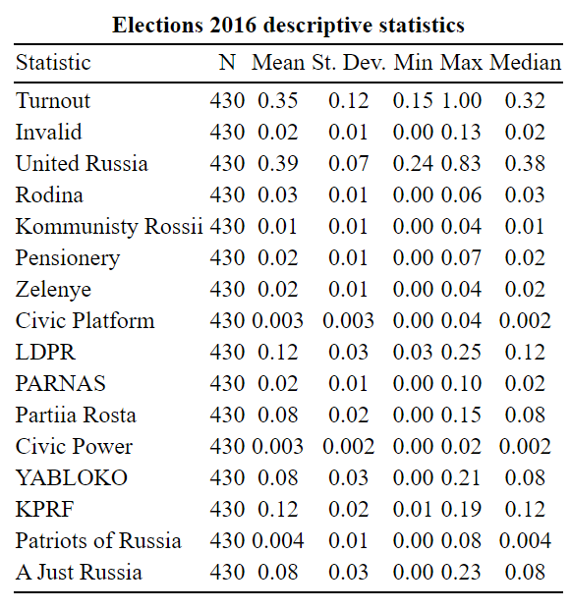

2. Table with the results of the OLS regression

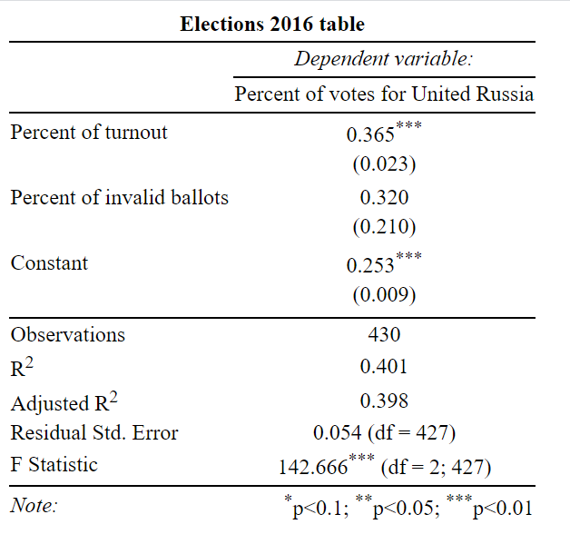

Statistically significant variables: Percent of Turnout (the \*\*\* indicates that p-value is really small)

The direction of relationship between the independent and dependent variables: positive (all the numbers are positive)

Predictive capability: R-squared is 0.401 which means that the model describes 40% of observations so predictive capability is not bad considering that I have only two predictor variables

Can the regression output be trusted? Yes, because F-statistic is pretty big

3. Results of model diagnostics

- on multicollinearity



the values are <10 so there is no multicollinearity and therefore no strong correlation between the IVs

-on heteroscedasticity

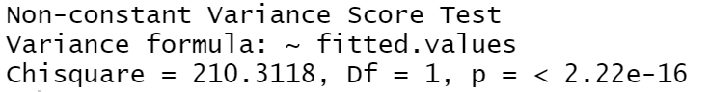

p-value is smaller than 0.05 so the problem of heteroskedasticity is present

-on outliers

There are two outliers in the model (rows 147 and 375)

there are no influential cases in the model as there are no cases in which cook's distance would be greater than 1

-on interaction effect

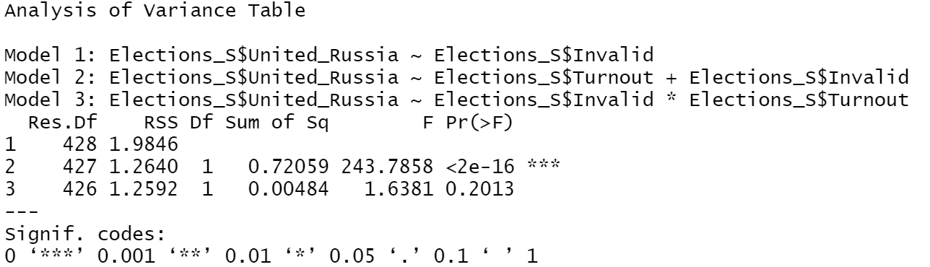

There is no interaction effect as p-value is too large and the additive model is more significant (\*\*\* indicates that)

4. Results of model diagnostics on endogeneity

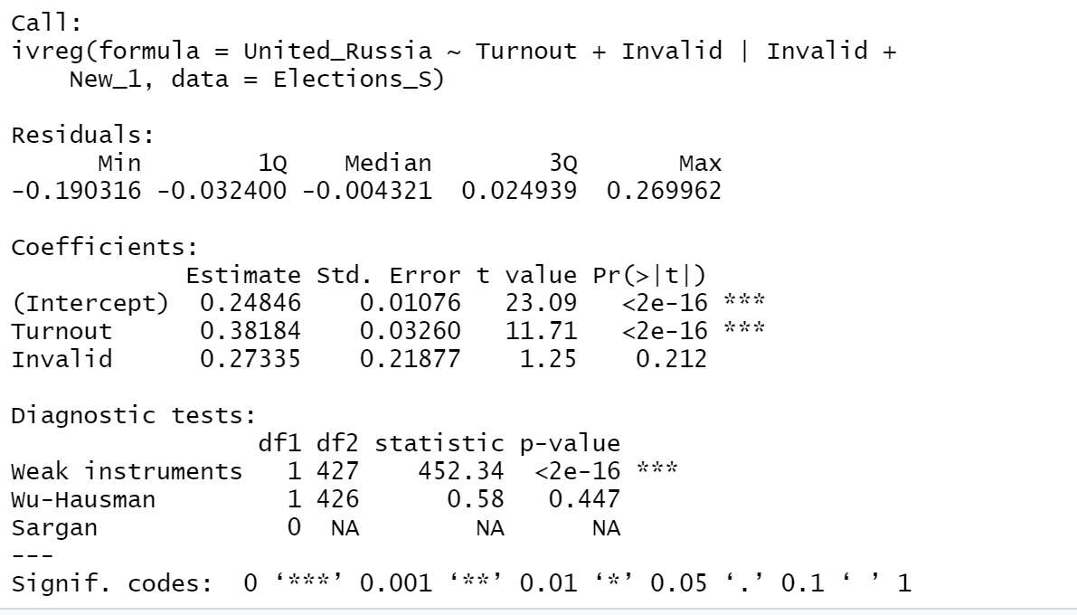

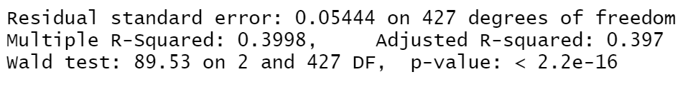

p-value is smaller than 0.05 so there is endogeneity